CAPE COD DART LEAGUE
COMBINED LUCK OF THE DRAW
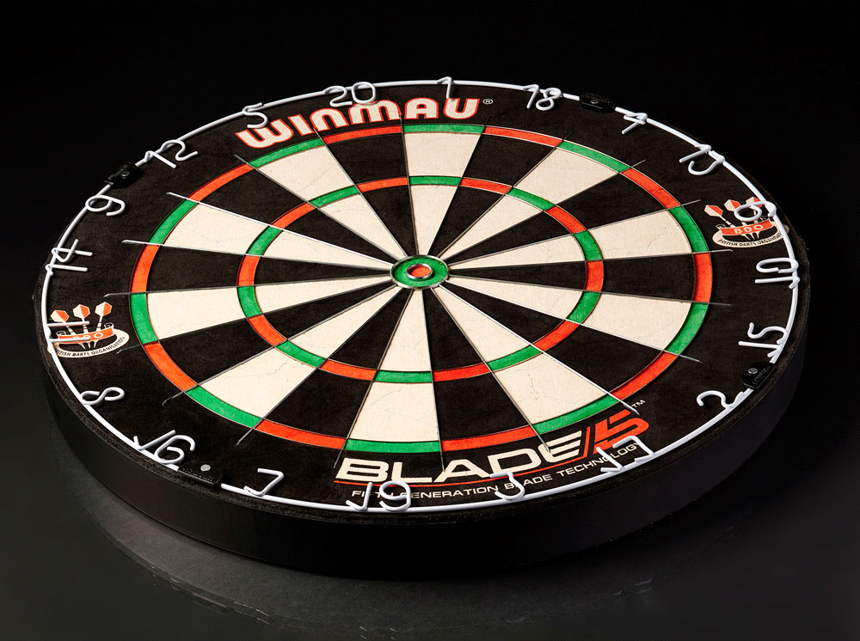
B & C
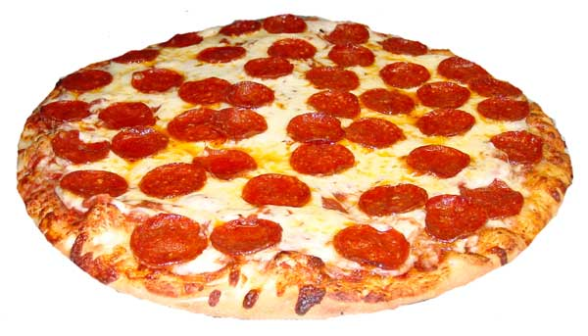
HELD AT THE BREWSTER PIZZA
SATURDAY April 13TH 2024
SIGN UP'S AT 6:00-6:45 PM WITH A 7:00 PM START TIME
SINGLE OR DOUBLE ELIMINATION DEPENDING ON # OF SHOOTERS
MUST BE A CCDL MEMBER IN GOOD STANDING TO PLAY
501 SI/DO - CRICKET- CHOICE
$10 ENTRY FEE AND CCDL WILL MATCH POTS UP TO $400
THERE ALSO WILL BE A 50/50 RAFFLE

